# **Define a problem:**

A chip is a semiconductor material that exists in every aspect of our lives, from householdappliances to the defense industry, from the automotive industry to technology.The main chip manufacturing factories in the world are: Global Foundries (based USA), TSMC (Taiwan), SMIC(China),Samsung (South Korea) and Intel (USA).Silicon, one of the raw materials of the chip, is also supplied from China.

The chip crisis, which entered our lives with the pandemic, has affected the automotive sector mostly.Lack of chip resource in main automotive industries such as Ford ,Hyundai,Volskwagen Toyota caused a break in production for a while.

A shortage in the supply of semiconductors has had a cascading effect, causing global disruption. The shortage can be traced back to the first half of 2020, when overall consumer demand for cars declined during the lockdown.

Automobile manufacturers, in particular, cancelled orders, while chip manufacturers shifted their focus to consumer products in an attempt to meet the pandemic's growing demand. After retooling their operations to produce chips for consumer items rather than automobiles, a shortage of automobile chips ensued.



Figure 1: Microchips are used from the automotive industry to the electronic industry. Most of the machines we use regularly in our daily life contain microchips.

**WHAT IS A SEMICONDUCTOR CHIP?**

A semiconductor chip, also called a microchip, serves as the “brain” of modern electronics. Manufactured from silicon, these highly engineered components are essentially a type of electric circuit. They include a series of transistors that function as tiny switches to control the flow of electrons.

Microchips can differ greatly in their complexity. For example, most credit cards feature a very basic chip as an added security measure. High-end computer processors, on the other hand, are incredibly complex. Today, these chips are used in nearly everything, from cars and smartphones to refrigerators and electric toothbrushes.

They’re extremely small, too (hence the name microchip). According to Intel, a leader in chip manufacturing, a single chip transistor is about 10,000 times smaller than a human hair! And to build a modern processor, billions of transistors are packed into an area about the size of a fingernail.

**MEASURE:**

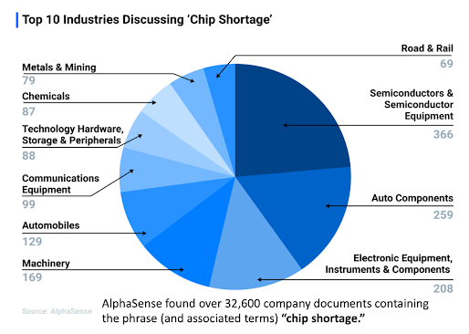

Figure 2: According to researches, many industries, especially semiconductors, auto components, electronic equipment, suffer from chip shortages.

The lack of semiconductors affects a range of industries, including advertising. The chip shortage is limiting the availability of digital equipment, including lighting and screens for ads.

Semiconductor chips are extremely important components of new vehicles for areas like infotainment systems and more basic parts such as power steering and brakes. Depending on the vehicle and its options, experts say a vehicle could have hundreds of semiconductors, if not more. Higher-priced vehicles with advanced safety and infotainment systems have far more than a base model, including different types of chips.

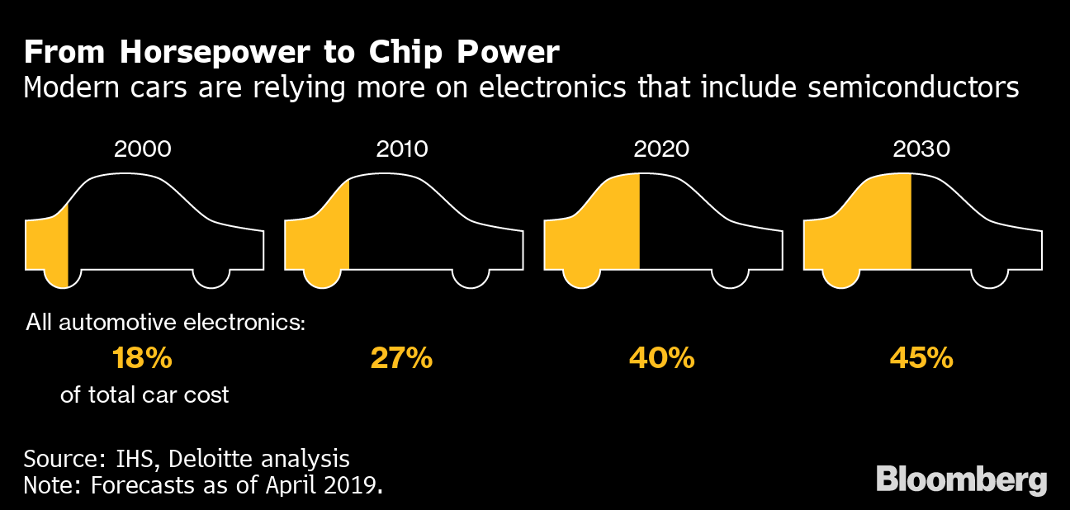

There are cqup to 1400 chips in a typical vehicle today, and that number is only going to increases as the industry continues its march toward electric vehicles, ever-more connected vehicles and, eventually, autonomous vehicles,” Dan Hearsch, a managing director in AlixPartners’ automotive and industrial practice, said in a statement. “So, this really is a critical issue for the industry.”

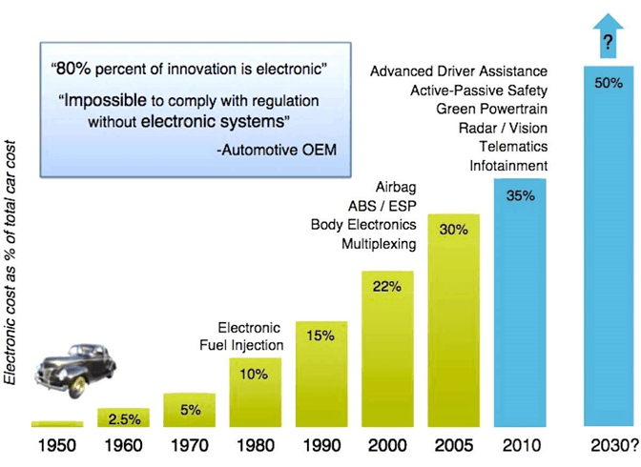

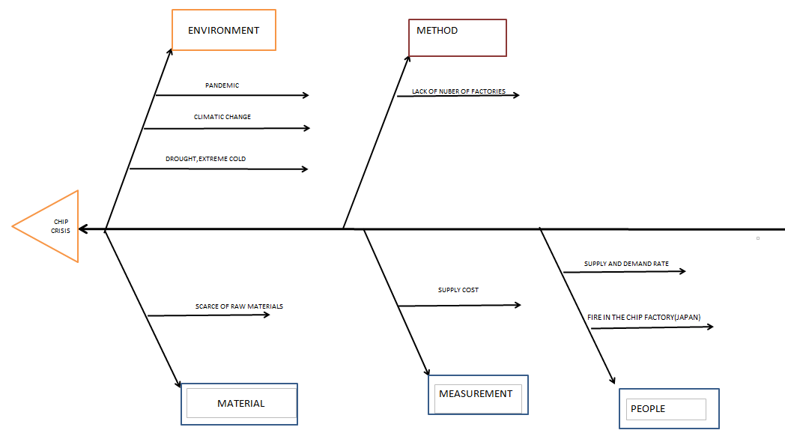**Fish bone diagram:**

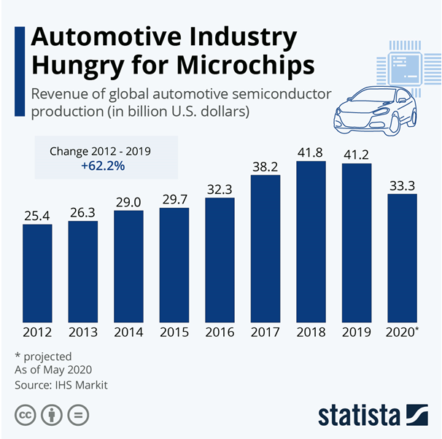

Figure3: We can see from this table how much the revenue has decreased in 2020 due to the chip crisis in the automotive industry.

In 2019, the [auto industry](https://time.com/tag/auto-industry/) spent $43 billion on chips—but they made up just 10% of the total chip market. The world’s largest foundry, [Taiwan Semiconductor Manufacturing Company](https://time.com/collection/time100-companies/5950050/taiwan-semiconductor-manufacturing-corp/) (TSMC), supplies more chips than anyone else to the automotive industry—but the automotive industry makes up just 3% of its revenue. (Apple makes up more than 20%.) At GlobalFoundries, chips destined for cars accounted for less than 10% of its business—enough to matter, but not enough to set the clocks.

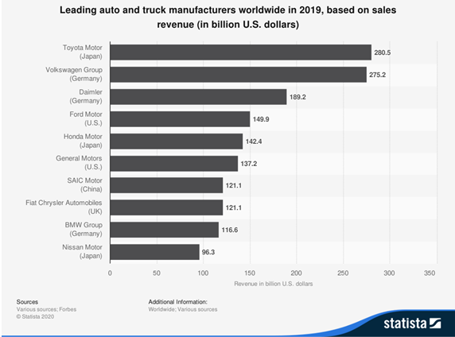

Figure 4: It is seen in the table that the income in 2019 is much more positive than in 2021.

Chip shortage expected to cost auto industry $110 billion in revenue in 2021.The semiconductor chip shortage is expected to cost the global automotive industry $110 billion in revenue in 2021, according to consulting firm AlixPartners. The forecast is up by 81.5% from an initial forecast of $60.6 billion in late January.

A number of factors have contributed to the increase, including a fire at a chip supplier plant near Tokyo and weather-related kinks in the automotive supply chain.

Tomakers such as Ford Motor and General Motors expect massive earnings cuts this year due to the chip shortage. Ford said theq lower its earnings by about $2.5 billion in 2021. GM expects the chip shortage will cut its earnings by $1.5 billion to $2 billion.

**How the shortage is affecting firms:**

* Renault forecasts its car production could be down by about 100,000 this year
* Sony says it is difficult for it to bump up production of the PS5 consoles
* Apple expects the impact of the shortage to worsen and extend to iPhone production
* Tesla says it is using alternative chips and rewriting software
* Taiwan Semiconductor Manufacturing plans to build new factories in the US and Japan
* Toyota is to slash worldwide vehicle production by 40% in September because of the global microchip shortage.

The world's biggest carmaker had planned to make almost 900,000 cars next month, but has now reduced that to 540,000 vehicles.

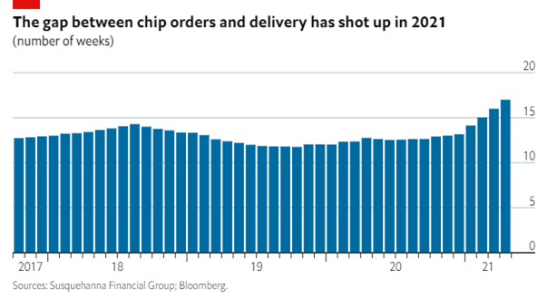

Figure 5: In this graph we can see the difference between the chip order and the chips sent. This means that the demand for chips cannot be met and the gap is getting bigger.qq

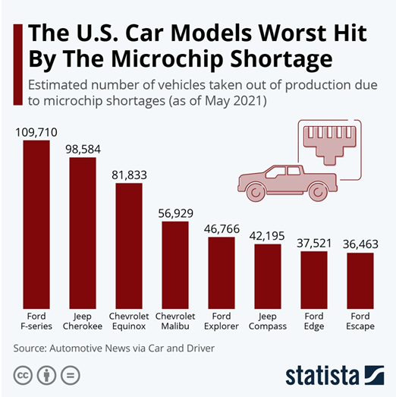

Figure 6: We see the decrease in the production of cars due to the chip crisis in the table. The production of many vehicles was stopped due to lack of chips.

**ANALYSIS:**

**Supply and Demand Gap**

Chinese tech company Huawei had also placed large orders from Taiwan's largest chipmaker TSMC and other Taiwanese manufacturers to secure enough chips before the sanctions went into effect in September. Meanwhile, Taiwanese chip manufacturers have been busy fulfilling orders from the electronics industry due to the increasing demand for laptops, game consoles and smartphones due to the pandemic. In other words, Taiwanese manufacturers had to meet very high orders all of a sudden. On top of that, when the automotive sector, which returned to the field faster than expected after the epidemic measures and started production, started to order chips again, chip manufacturers that were already working at full capacity could not meet this demand. Consumer electronics have gone so far in chip demand that Apple alone is asking for as many chips as the entire automotive industry.

**Chip Material**

Because chips are light assets, both in cost and in cost, it is not profitable to produce them in small factories and on a small scale. Therefore, economies of scale apply in chip manufacturing; that is, as you produce in very large quantities, the cost decreases and the producer gains from the version. Small manufacturers do not have a chance in this market because only giant companies can meet the increasing orders.

According to Reinhard Ploss, CEO of chip maker Infineon, although the chips are small in size, they do not have stacking properties and the chips have an expiration date. For this reason, the order must be placed at the right time so that the chips can be delivered to the customer on time.

Figure 7: Thousands of chips are needed in many parts of a car. They all perform different functions.

**Drought**

Water has a great place in chip production and pure water is used.

In Taiwan, the home of companies such as Taiwan Semiconductor Manufacturing Company (TSMC), the world's leading semiconductor chip manufacturer that manufactures for companies such as technology giants Google and Qualcomm, the drought across the country has affected chip supply.

As the drought restricted water use, the factories of chip manufacturers operating in the country suffered from water shortages. Adversely affected its production.

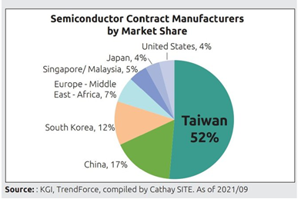

Figure 8: We can see on the table semiconductor contract manufacturers by market share mostly in taiwan.

**Extreme Cold:**

The extreme cold in the US state of Texas caused a power outage. Therefore, the production of mass-produced chips was disrupted. And the chip industry, which required continuous production to meet the demand, affected.

**Machine:**

In order to produce chips, a precision measuring device which called ‘nitography’ is needed. The biggest company producing nitography in the world is the Dutch-based company called ASML. A chip is needed to produce nitography. And this bottleneck causes an astonishing paradox.

**Source of raw material:**

Silicon is the most indispensable mineral to produce a chip. It is very difficult to extract and process this mineral, which is one of the most basic materials of the chip. It takes a long time to process this metal and make it useful. And this inadequacy in the number of silicon could not meet the increasing chip demand.

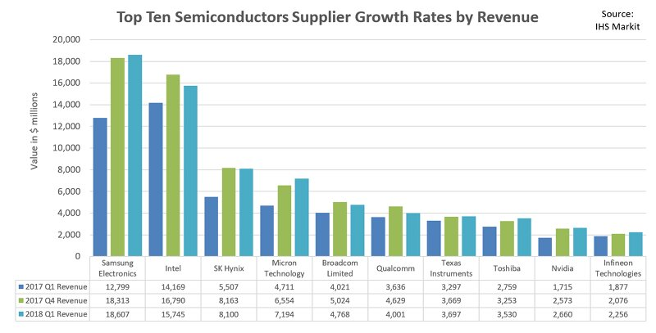Due to the pandemic, the low demand for technological tools in the automotive sector has caused technology companies to demand more chips from suppliers, and the automotive sector to demand less chips. Chips produced for technology companies require advanced technology and are more profitable for suppliers. has signed an annual promissory note. This has caused a great problem for the automotive industry to find chips.

**Pandemic:**

The only thing it seemed no one needed was a new car, at least at first. Sales were off by a third in April, May and June 2020. Auto-component makers—not the brand-name car companies but their suppliers, and their suppliers’ suppliers—canceled orders.

But a semiconductor fab can’t turn on a dime. Foundry is the chip-industry term for a contract manufacturer, like a $15 billion Kinko’s. GlobalFoundries alone prints chips for more than 250 customers, which in turn supply components to device manufacturers—big, familiar names like Apple or Samsung, as well as industrial brands like Continental or Bosch. The supply chains are long. It takes three months to bake a chip. On any given day at GlobalFoundries, there might be only 10 different kinds of chips in some phase of production.

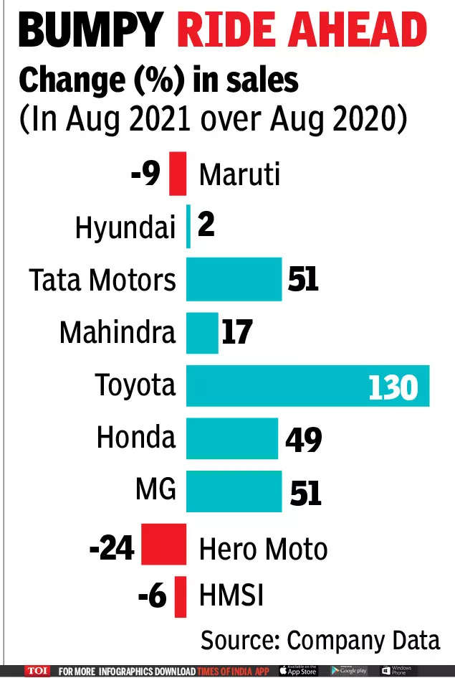

Figure 9-10: Due to covid-19, car sales in the world have decreased compared to brands and countires.. This is a major factor in the chip crisis.

**IMPROVE:**

**1)**Building new factory

Pros:

* Being independent on foreign sources
* Decrease trouble finding chips
* Be more profitable in the long run for the automotive industries

Cons:

* Semiconductor factories cost billions of dollars to build
* Establishing new chip factories is difficult to do quickly
* It's extremely expensive and requires a well-trained workforce
* Necessary area

2**)** Produce chips in own factory by obtain necessary machine

Cons :

* Machine is expensive
* Producing cost
* Place issue

Pros:

* Decrease lead time
* Eliminate factory contruction cost

**3)**Chip companies keep secret how efficient their fabrication processes are. However, the yield is estimated to be between 70% and 90%. They show an effort to improve chips, some parts of which are damaged in production. For example, Intel might design an 8-core chip and sell it as a 6-core because one or two of its cores were damaged in production and disabled them. This chip, whose 2 cores are damaged, sells it as 6 cores to minimize the damage.

Pros:

* Evaluating the part that will be completely thrown away
* No loss even if no profit is made from the part to be damaged

Cons:

* Less chips on the market
* Not making a profit when profit can be made 3- Time and cost spent in the improvement process
* Losing damaged chips

**4)**Software Solutions: Smart Compression And Compilation

Unlike hardware, software has the potential to be deployed globally at the speed necessary to keep the industry’s promises of AI-powered cameras, speech and face recognition, augmented reality and so on. Up until now, lack of efficiency has prohibited the industry’s adoption of software as a solution for the chip shortage and to achieve AI models on edge computing devices.

When it comes to machine learning, smart compression and compilation is much more than just keeping download sizes low. In order to reduce the size and power demands of a working model, it’s important to consider what parts of that model are necessary to its outcomes. Thus, smart compression involves “pruning” — removing layers, filters or channels in the model without unduly reducing its accuracy. It also involves “quantization,” finding places where precision can be reduced to save computation cycles (again, without affecting the outcome).

Compilation maps the high-level operations of the compressed model to the low-level ones supported by a chip’s architecture.That’s why,using software and machine techniques will be helpful to reduce equipment usage as well as equipment cost.

## Control:

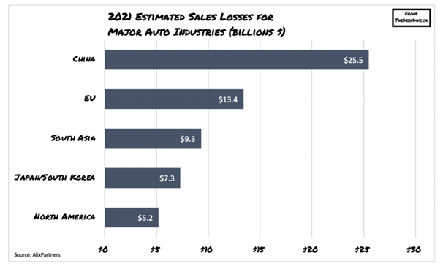It ıs obviously seems that building a new chip factory is more advantageous when economic, time and other factors are compared.

Figure 11: The chip crisis has affected every part of the world. Thus it became a universal problem. In the 21st century, when we live at the most advanced level of technology in the world, many countries that appear in the table have experienced a decrease in their sales.

Looking at the table above, the annual losses due to the chip crisis in the world in 2021 are 60.7 billion dollars, while the cost of establishing a new factory is 20 billion dollars. The construction of the factory is expected to take approximately 2 years. thus, in 2023, it may be able to meet new factory chip orders. Already, experts predict that the chip crisis will end in 2023.

### References:

<https://www.nippon.com/en/japan-data/h01107/>

<https://www.mckinsey.com/~/media/mckinsey/industries/semiconductors/our%20insights/mobility%20trends%20whats%20ahead%20for%20automotive%20semiconductors/svgz_mobility_trends_automotive-semiconductors_ex5.svgz>

<https://semiengineering.com/automotive-semiconductors-boost-mcu-analog-markets/>

<https://semiengineering.com/automotive-semiconductors-boost-mcu-analog-markets/>

<https://www.statista.com/chart/24504/revenue-of-global-automotive-semiconductor-production/>